

**MACHINE JOB SCHEDULING**

**Software Requirement Specification (SRS) Document**

**Sprint 1 Implementation**

**Project Timeline: 07.09.2022 to 14.09.2022**

**INDEX**

1. Introduction

1.1 Purpose --------------------------------------------------

1.2 Intended audience --------------------------------------------------

1.3 Intended use --------------------------------------------------

1.4 Scope --------------------------------------------------

2. Overall description --------------------------------------------------

2.1 Assumptions and dependency --------------------------------------------------

3. System feature and requirements --------------------------------------------------

3.1 Functionality --------------------------------------------------

3.1.1 Frame Number function —-----------------------------------------------

3.1.2 ScoreSoFar function --------------------------------------------------

3.1.3 GameIsOver function --------------------------------------------------

3.1.4 Roll function --------------------------------------------------

3.1.5 Bowler database --------------------------------------------------

3.1.6 Bowling database --------------------------------------------------

3.1.7 Bowler_data_sheet function --------------------------------------------------

3.1.8 Bowler_day_report function --------------------------------------------------

3.1.9 linkedlist_to_file function --------------------------------------------------

3.1.10 file_to_linkedlist function --------------------------------------------------

3.2 System requirement --------------------------------------------------

3.2.1 Tools to be used --------------------------------------------------

3.3 System feature ------------------------------------------------

4. DataFlow Diagram

4.1 DFD level 0 ------------------------------------------------

4.2 DFD level 1 ------------------------------------------------

### **1.** **Introduction: -**

The introduction of the software requirement specification provides an overview of the entire software. The entire SRS with overview description purpose, scope, tools used and basic description. The aim of this document is to gather, analyze and give an in-depth insight into the complete Machine Job Scheduling application by defining the problem statement in detail. The detailed requirements of the Machine Job Scheduling application is provided in this document.

**1.1** **Purpose**: **-** The purpose of this document is to show the requirements for the “Machine Job Scheduling Application”, in which we will process jobs data and assign requested machines to the jobs then schedule for each machine is generated.

**1.2** **Intended Audience: -**This document is intended to be read by, Client.

**1.3** **Intended Use: -**

* Development Team
* Maintenance Team
* Clients

Since this a general-Purpose Software any one can access it.

**1.4** **Scope: -**

In a manufacturing company, there are three machines to do manufacturing jobs in which the jobs are received from clients in separate text files. The machine job scheduling application is to be developed, which will be processing the jobs data and then assigning requested machines to the jobs. A schedule for each machine is generated in text files.

**2. Overall Description: -**

This project aims to create the development of a Machine Job Scheduling Application. Which takes the Job description files as input which contains information like: Job No, Description, Machine No, Duration(in minutes), Client name (optional). Three machines are resources to be shared among jobs. All machines start at time T1. Whenever a machine is allocated to a job its time will advanced by “Duration” and an entry will be written in “Schedule". Schedule entries contain - Job No, Start time, End time.

**2.1 Assumptions and Dependency: -**

* System should have Ubuntu Linux installed.
* · System should have either 4GB or more RAM.
* The service is used preferably on a desktop or laptop.

**3.System Features and Requirements: -**

**3.1 Functionality: -**

**3.2 System Requirements: -**

### **3.2.1. Tools to be used:**

* Pthread Library
* C File Handling
* C Language
* System Programming
* Gprof
* Gcov
* Cunit
* Valgrind
* Splint
* GDB

### **3.3 System Features: -**

### Supportability:The system is easy to use.

* Design Constraints: The system is built using only C language.
* Usability:The automatic bowling scorer application can be used to replace the old means. Recording score by displaying various information to the player such as number of pins knocked down by each ball, the frame number which is currently going on, the cumulative score gained throughout the the end of each frame and the total number of points scored by the player after the completion of a total of ten frames.
* Reliability & Availability**:** The system is available 24/7 that is whenever the user would like to use the system, they can use it up to its functionalities.

### Performance: The system will work on the user’s terminal**.**

**4. DataFlow Diagram:**

**4.1 DFD Level 0 -**

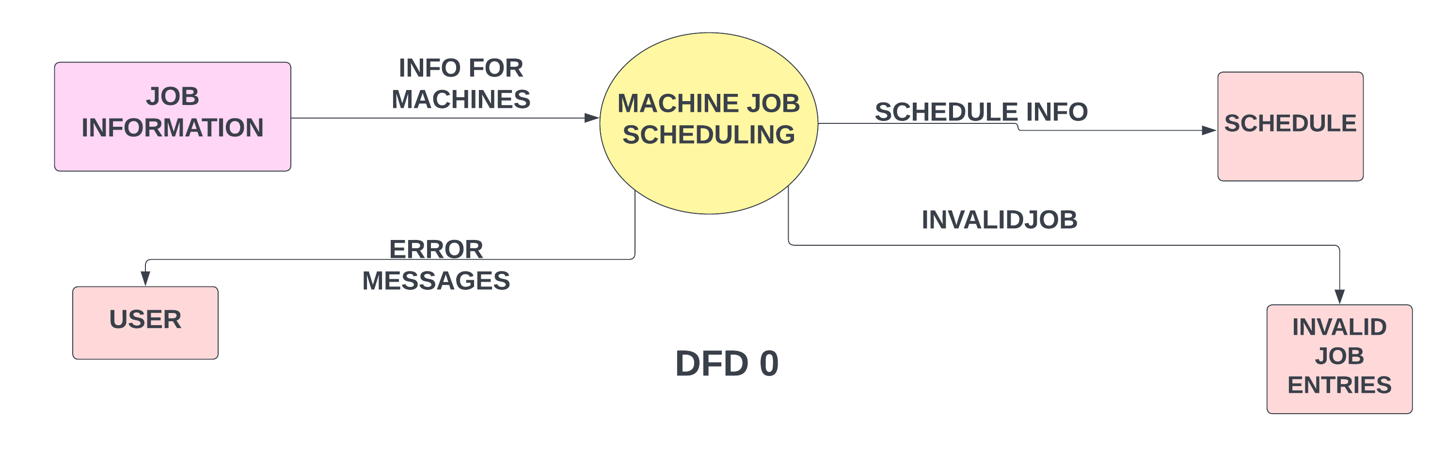

**4.1 DFD Level 1 -**

